Apify Apollo Scraper S.O.P
How to Scrape 7,000 Leads Per Week
Loom Video: https://www.loom.com/share/0119f12103cd46f8a2412fab76fe481b?sid=7c87dc9b-4089-46fa-9f1a-22b47a326b41

3 Things You Will Need:
- Apify Account
- Apollo.io Account(s)
- Access to Professional Emails
  - Business Domain
  - Not anything ending in “@gmail.com” or “@outlook.com” etc

Details About Scraper:
- Can only scrape 1,000 leads every 24 hours
- Data I use:
  - Full Name
  - Email
  - Phone Number (Formatted & Sanitised)
  - Location
  - Website URL
  - Personal LinkedIn URL

Getting Started

Step 1: Create an Apify Account
Apify: https://www.apify.com?fpr=2910f

Step 2: Create an Apollo.io Account with a Professional Email
Apollo: https://www.apollo.io/

Step 3: Get a 14-day free trial of Apollo’s paid subscription
You don’t need to put in your card details you can just redeem this. Very Easy.

If you have already redeemed a 14 day trial – DO THIS:
When you have a professional domain, you can create new users under your domain.
In Google workspace, as the admin, you can create new users very easily.
This may cost around $20.
Use this new user to create a new Apollo.io account and redeem your 14 day trial.

IMPORTANT:
After the 14-day trial is finished for that new user, DELETE THAT USER.
If you don’t delete the users you will be billed the monthly license for that user.

Step 4: Finding Your Leads in Apollo
When you enter into Apollo you will find a “Search” tab.
Then you want to search by “People”. This way we can find actual people to reach out to.

IMPORTANT: Segmenting Your Lists
Whenever you use Apollo, even with the paid versions, they only let you search up to 100 pages of any search.
There are 25 contacts each page, which means that we can only scrape 2,500 leads per search.
So, to work around these limits, we need to segment our searches.
And we want our search results to be close to 2,500 or UNDER.
What does segmenting my search mean?
When you’re searching for your leads it asks you to select the people you are looking for.
- What location (UK, USA, etc)
- What position (Director, Founder, etc)
- Company Size / Number of Employees
- Industry
We can break up our lists using these different filters.
For example,
If I want to reach out to Recruitment Companies in UK.
I could split them up by company size e.g. 1-10, 11-20, 21-50….
But remember, we want our search result to be close to or under 2,500.
So, we segment it further.

I might search:
Industry: Recruitment & Staffing
Location: United Kingdom
Company Size: 1-10
Job Titles: Founder

Here’s my result:
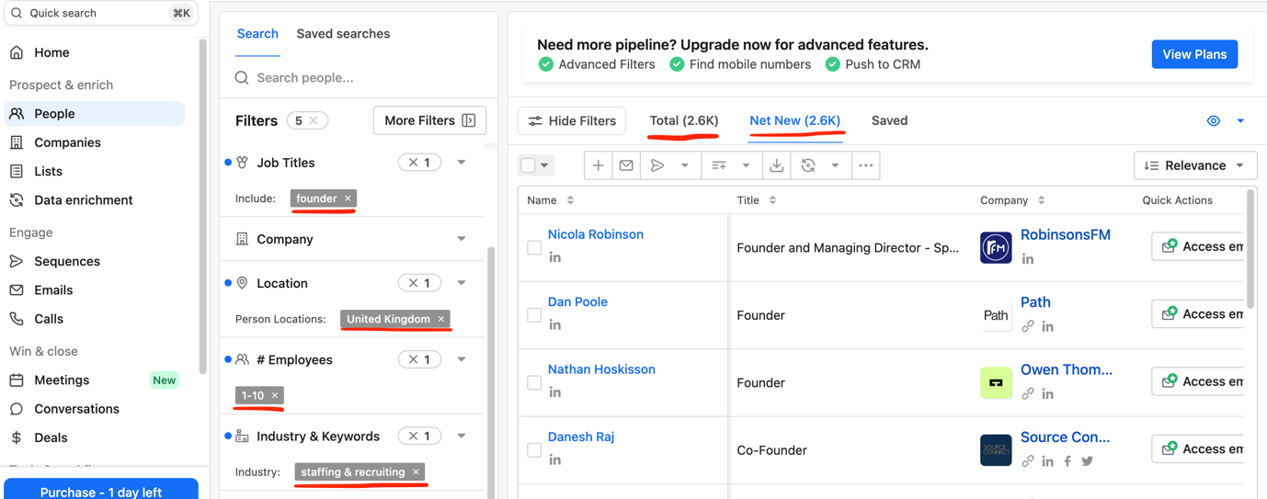

I got 2.6k results which is pretty close to our magic 2.5k.

Remember, we can only scrape 1,000 leads at a time, so I would only run this 3 times to get all of the leads.
My 3rd run would only get me 600 leads so its up to you if you want to leave those 600 to get 1,000 elsewhere or take the 400 lead hit for that day.

So, I would make a list of positions who are likely to be decision makers:
- Owner
- Founder
- Director
- Executive
- Manager…

Then I would take a note of how many search results we get for each position, here’s a very simple example:
Apify Apollo Scrape:
✅ = 1,000 scraped
1 - 10 Employees:
Positions:
Owner (1.8k) = ✅
CEO (1.2k) = ✅
Director (3k) = ✅
Executive
11 - 20 Employees:
Director (1.7k) = ✅
Executive (2k) = ✅
Manager (2k) =

__
Step 5: Using Apify To Scrape The Leads
Log into your Apify account and find the “Pay Per Lead” Actor:
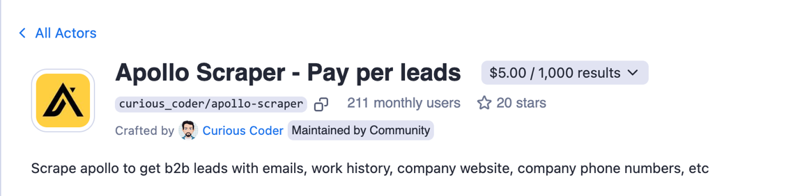
How To Actually Use This:
Your going to need to download an extension here, its called “Cookie Editor”
The one I use has this icon:

Once you have that downloaded, open a new tab (keeping your search tab open and intact) and we are going to export the Cookies from the Apollo website. Don’t be scared its very simple.
Step 1: Get on the homepage
Step 2: Open your Cookie Editor
Step 3: Hit the button on the bottom right that says “Export”
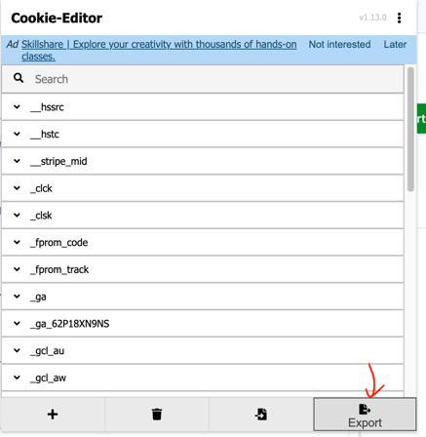
Step 4: Export as “JSON”
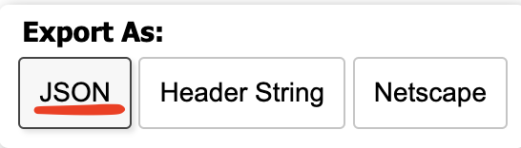
Once you hit this it should be copied to your clipboard.

Step 5: Go Into The Apify Apollo Scraper and Paste the JSON into the “Cookies” Box
Remove anything that’s in there before you paste your JSON into it.
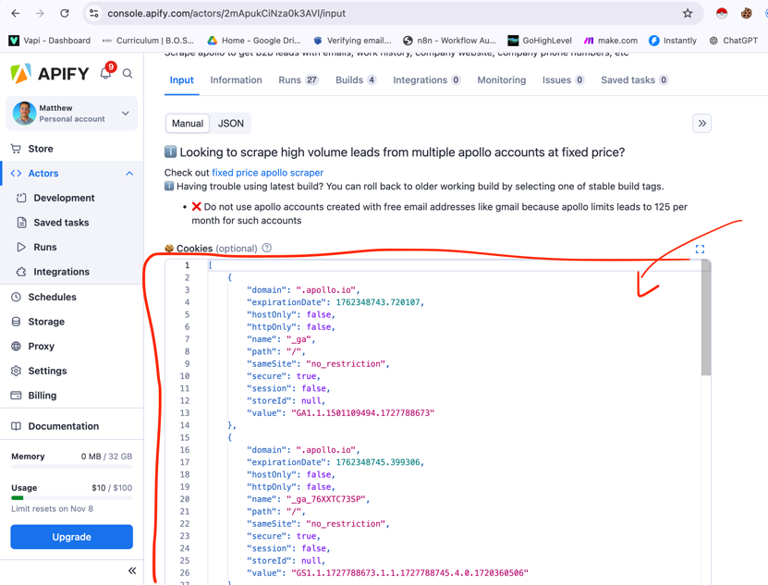

Step 6: Get the URL of your segmented search page
In the Apollo tab we kept open which had our segmented search, we want to copy the URL.
IMPORTANT:
Make sure on the search page, you have selected the “NET NEW”, this will avoid any complications with your scrapes if you want to scrape more leads from that same search URL.
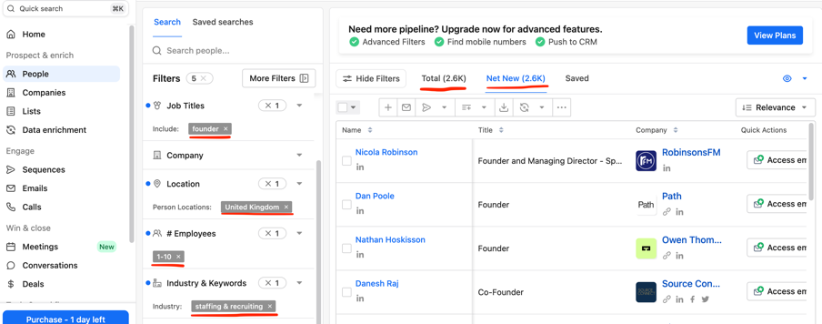
Once you have selected “Net NEW” and you have the URL, paste it into the Apify Scraper:
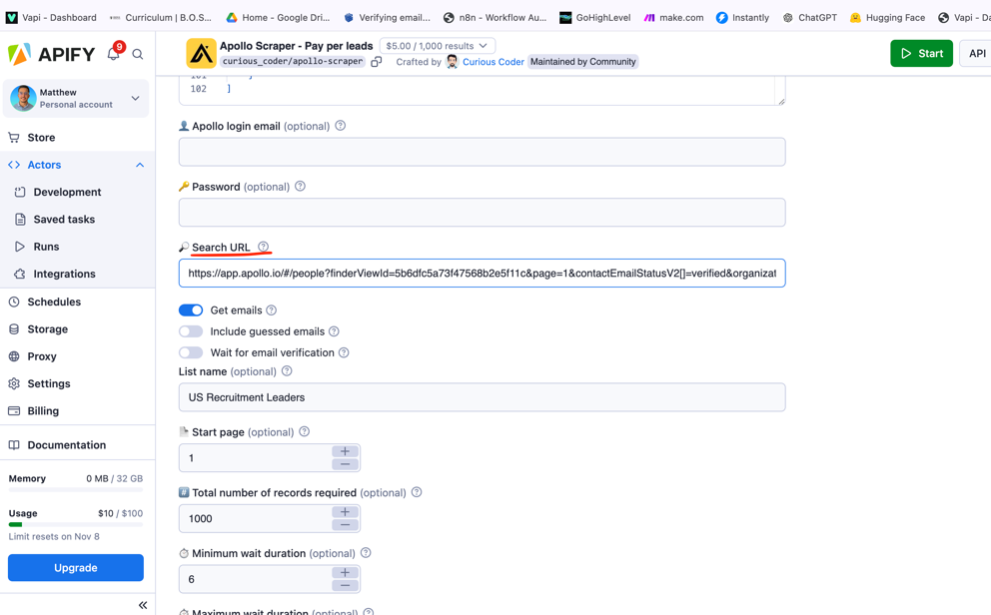

Step 7: Set The Rest of The Settings
As you can see from the image above I have selected:
- Get Emails (because we obviously want emails). Unselect the rest
- Name Your List
- Start Page = 1. This won’t matter if you have selected “Net New” as selecting this will reduce your duplicates by over 90%.
- “Total Number of Records” VERY IMPORTANT TO ONLY PUT 1,000 OR YOU WILL GET BANNED FOR 24 HOURS!!
- Minimum wait duration = 6 seconds
- Maximum wait duration = 10 seconds

Step 8: Hit Start
Once you hit start it should only take a couple of minutes and then you will have 1,000 leads and shit loads of information about them.
It is up to you what information you want to keep and how you want to organsie it.

